What is AWS WAF?
AWS WAF (Web Application Firewall) is a security service used to protect web applications from malicious internet traffic.
It filters and monitors HTTP/HTTPS requests before they reach your application.

Beginner Friendly Understanding
Imagine your website is a building.
People coming from the internet are visitors.
Some visitors are:
- Genuine users
- Hackers
- Bots
- Attackers
AWS WAF acts like:
A security guard at the entrance
It checks requests and blocks suspicious traffic.
Suppose you have:
- E-commerce website
- Banking application
- Login portal
Attackers may try:
- SQL Injection
- Cross-Site Scripting (XSS)
- Bot attacks
- DDoS attempts
AWS WAF protects your application from these attacks.

Let’s do a hands-on:
First lets create an ec2 instance and install web server in it
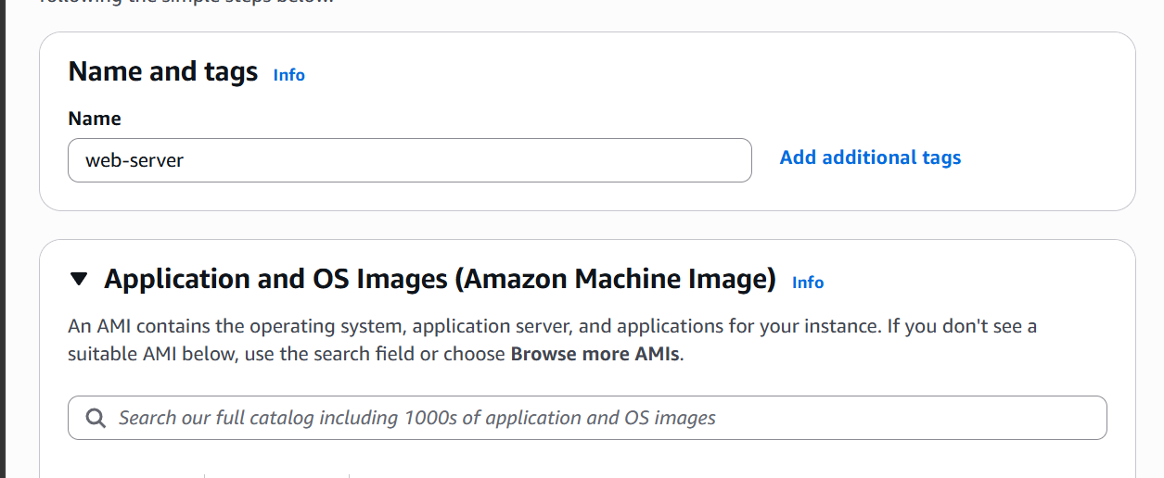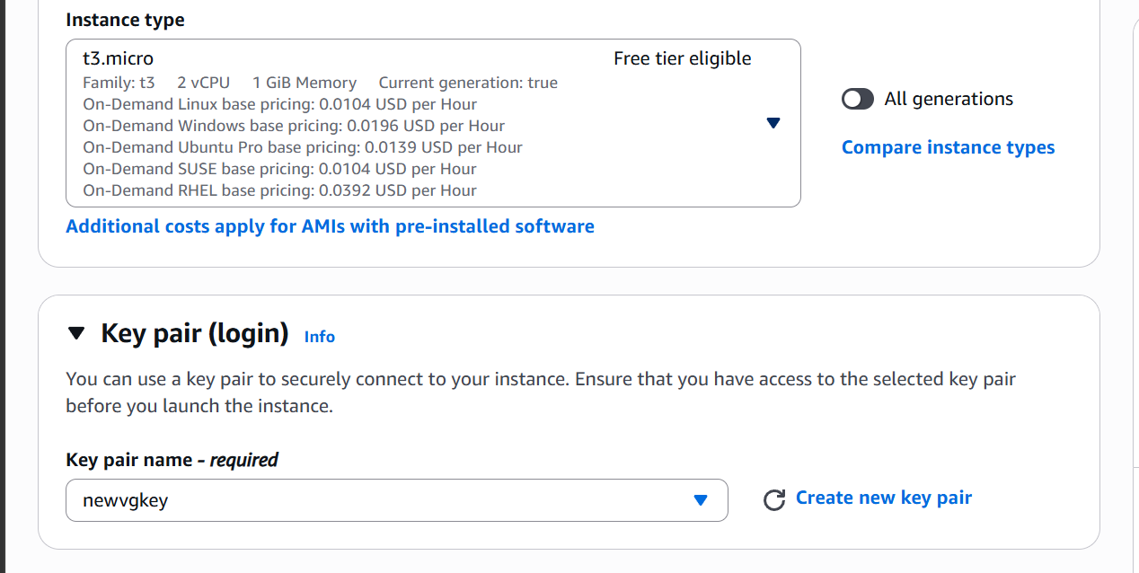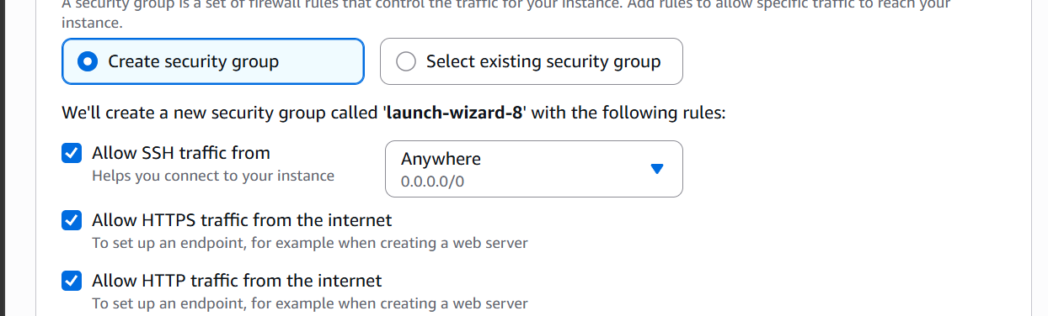
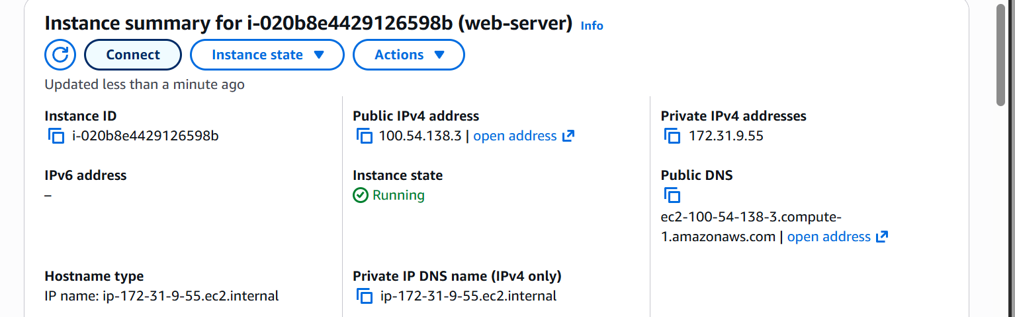
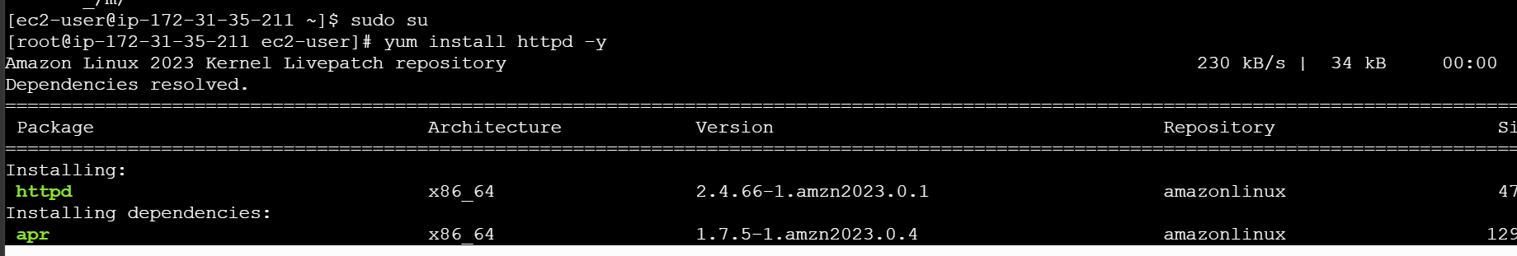

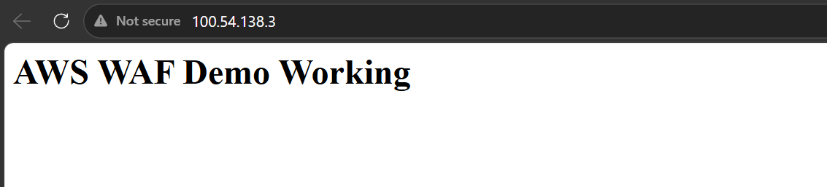

Our webserver is up and running

Now lets create target group
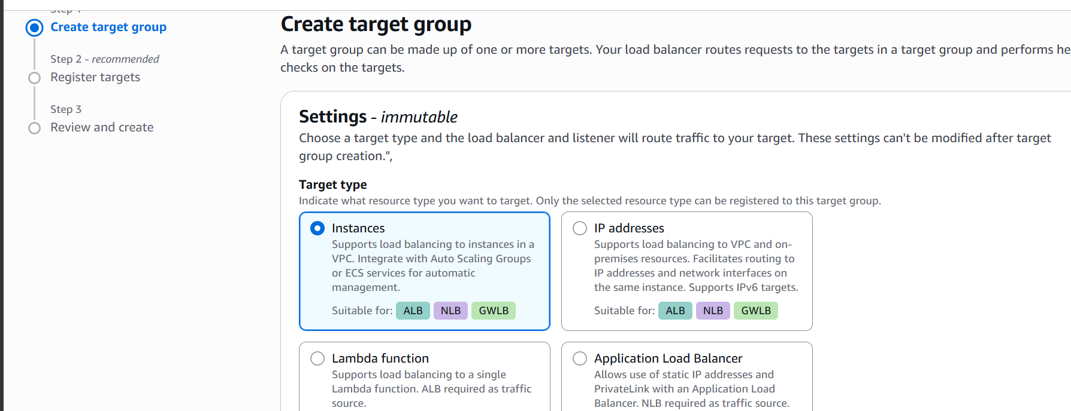
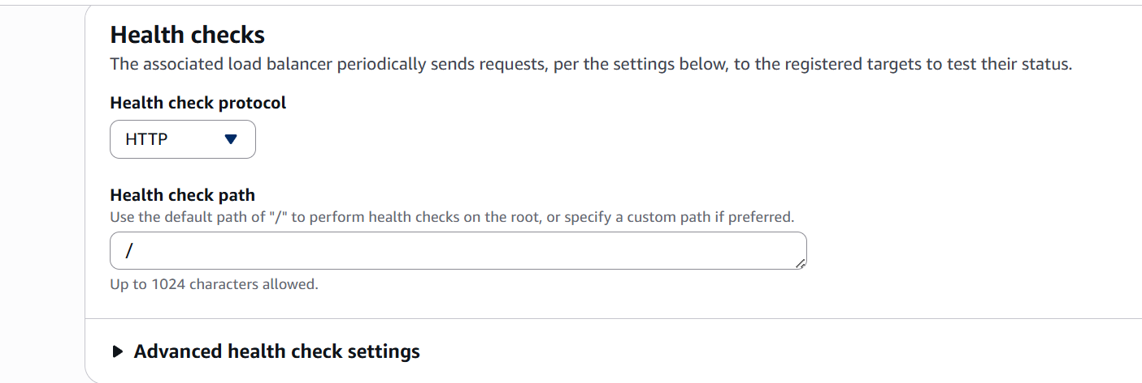
Register target
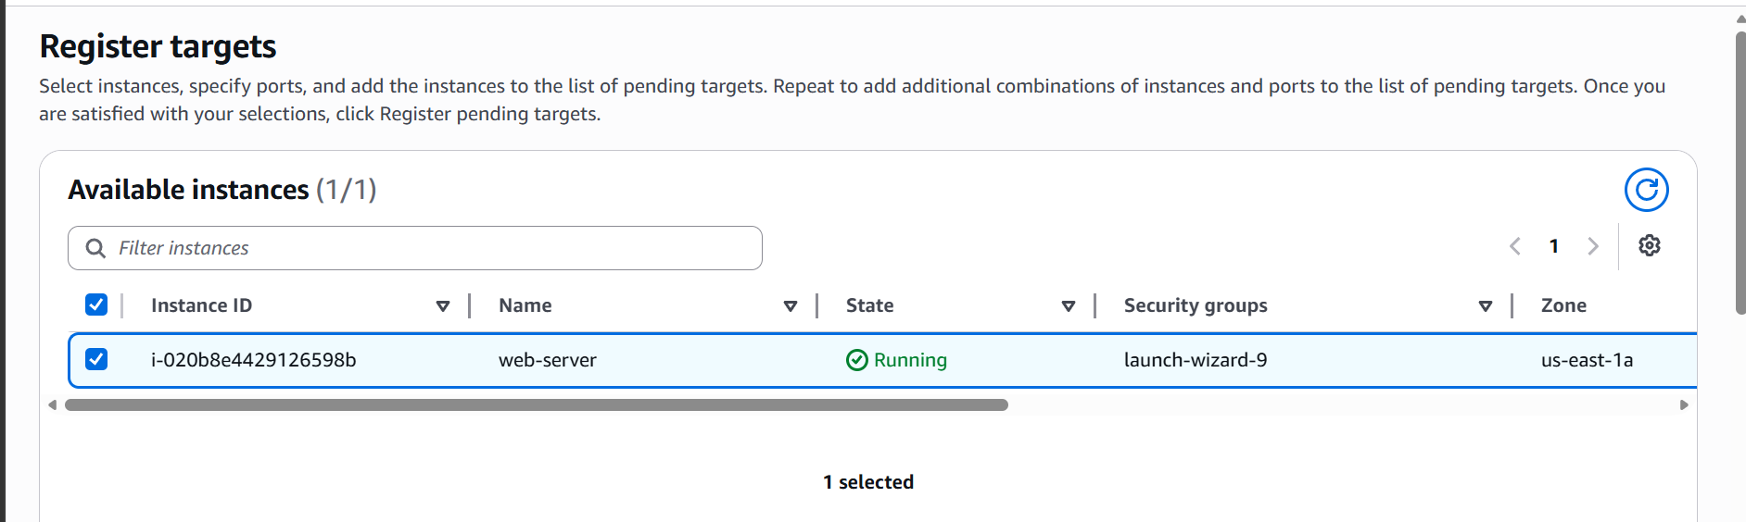

Target group is now created
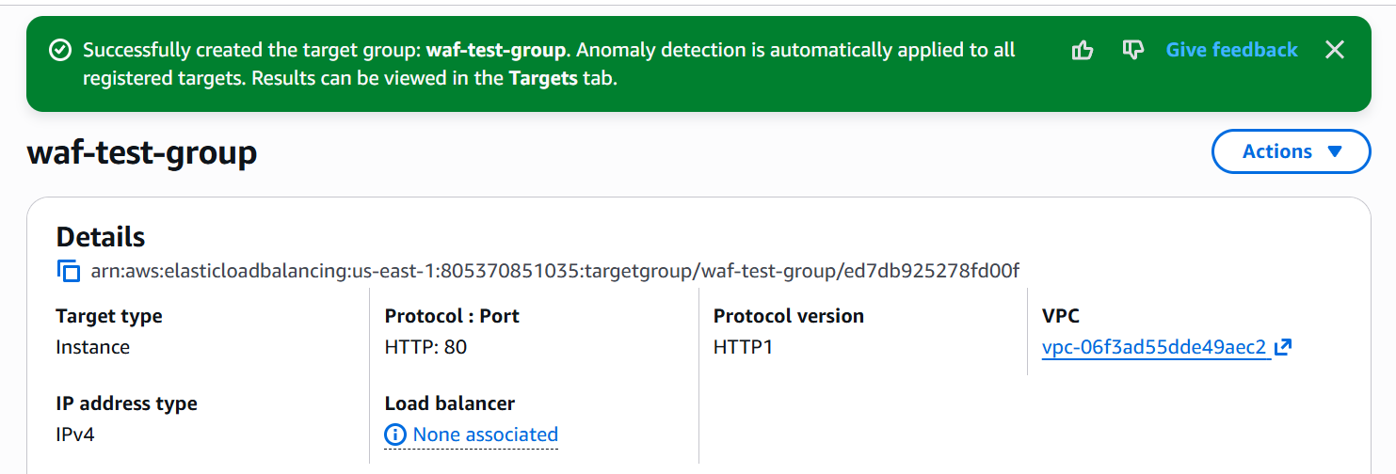
Now lets create a load balancer
Go to load balancers under ec2 options
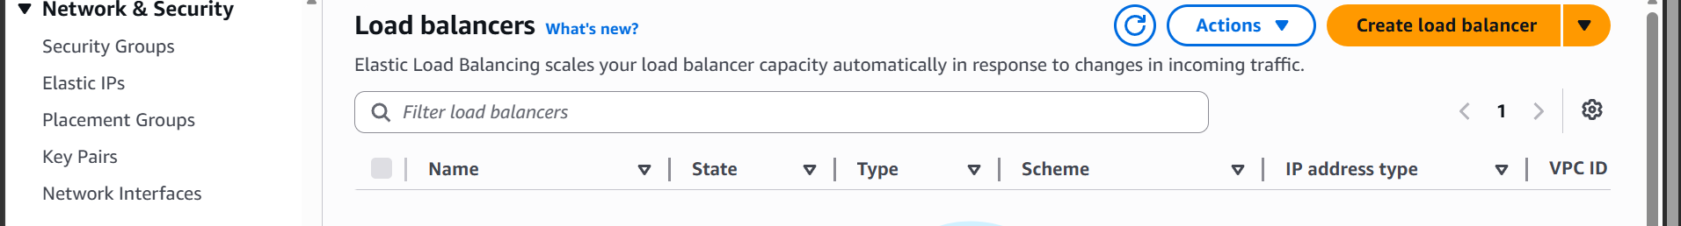
Select ALB as type
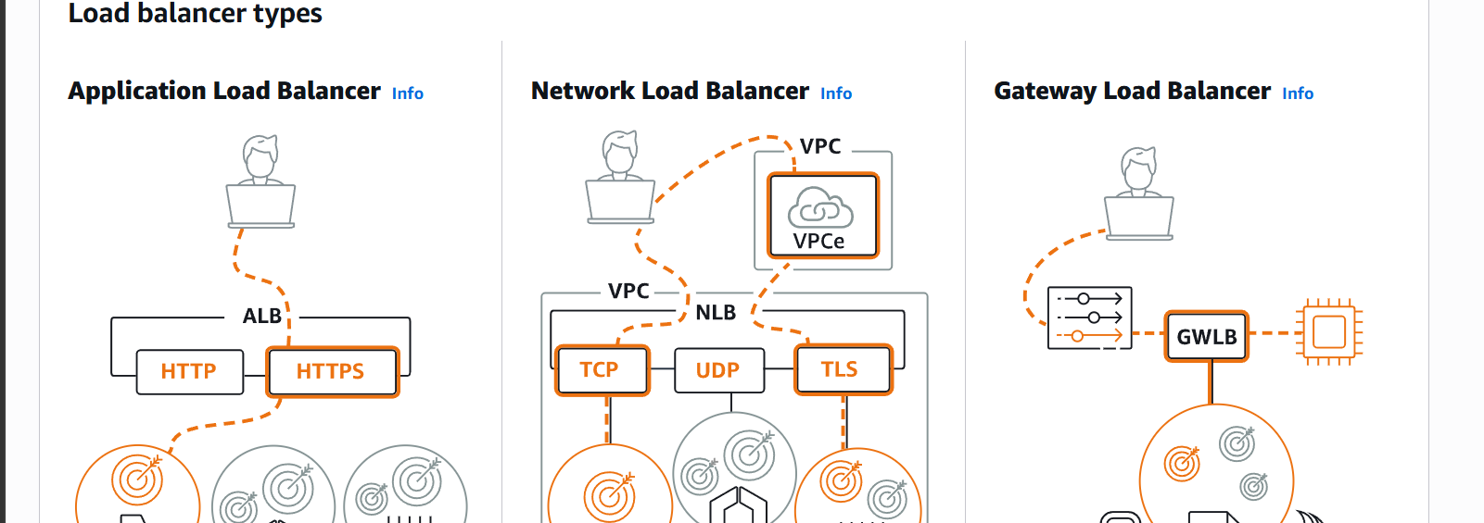
Click on create
Give load balancer a name and select scheme
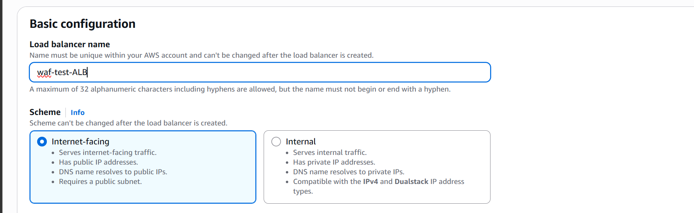

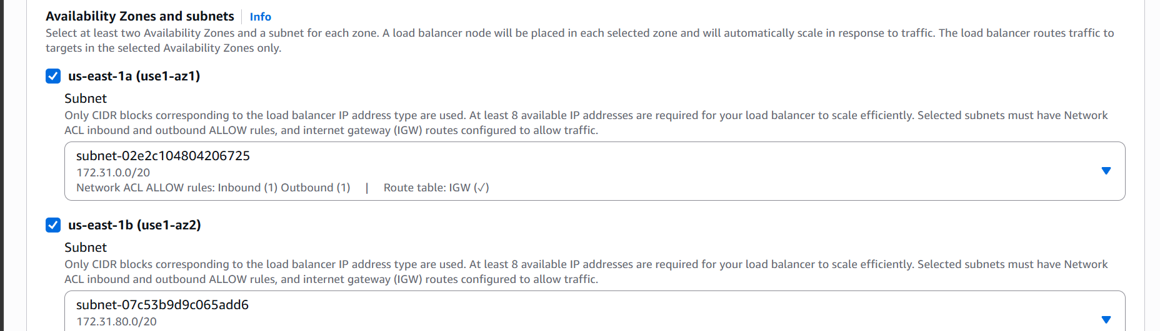
Select target group
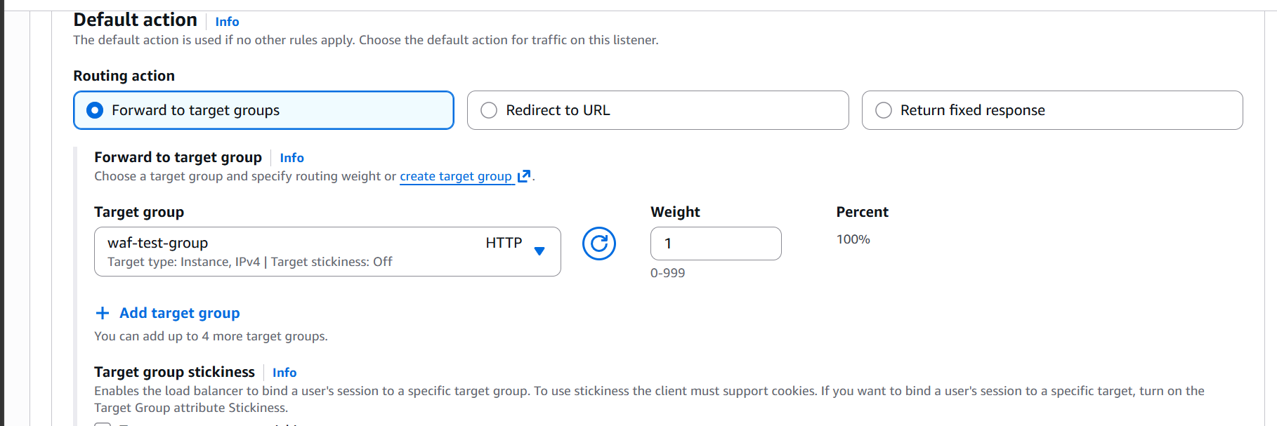

Now create load balancer
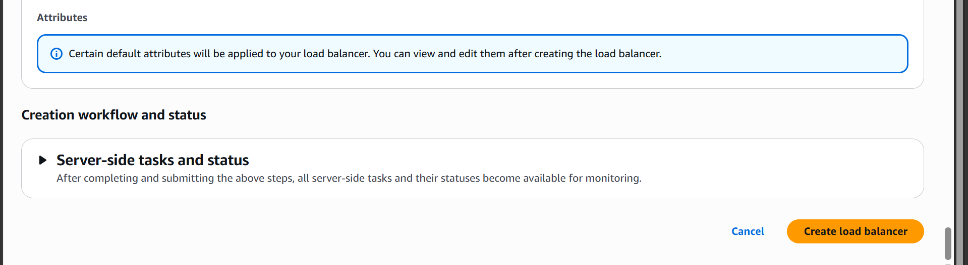

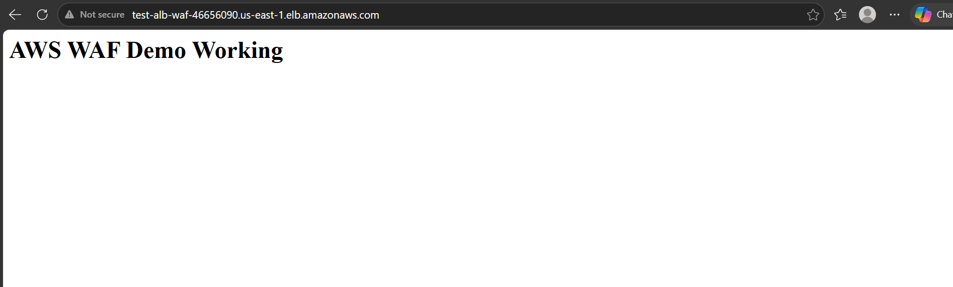

The load balancer dns is working
Now lets create AWS WAF
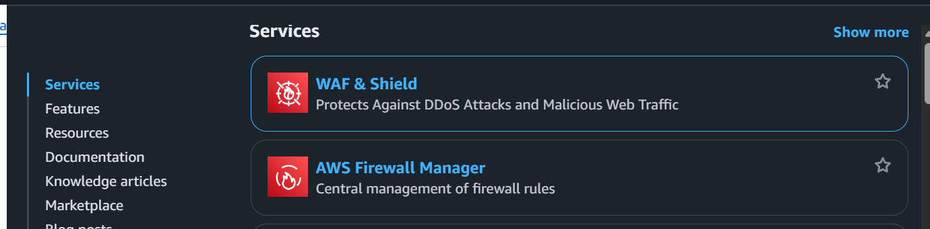

Click on WAF and sheild
And then create Web ACLS (Protection pack)
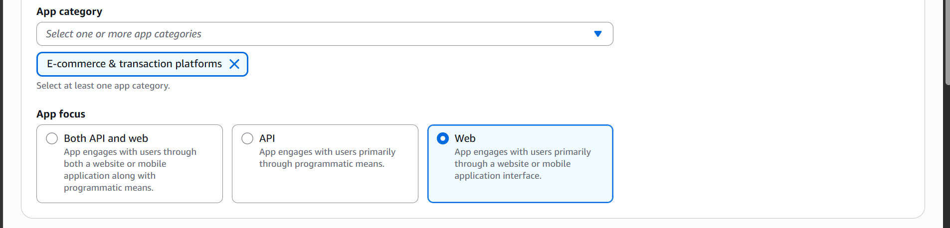
Select app category and app focus
Select resources to protect ALB in our case
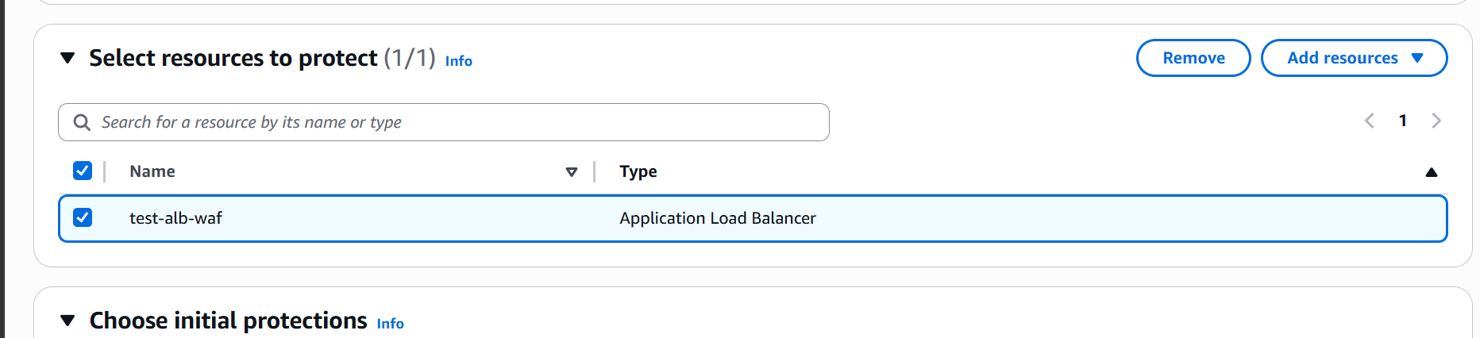
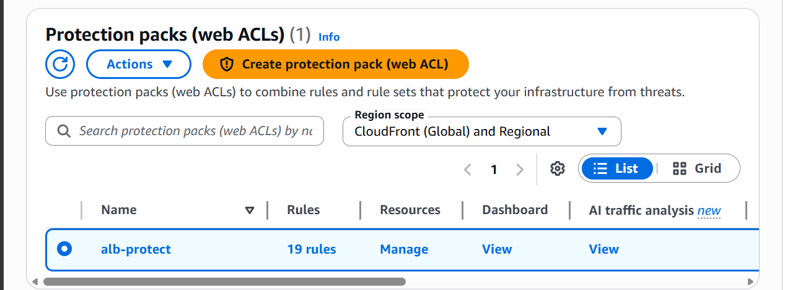

Web acl is created now
And It is associated to ALB
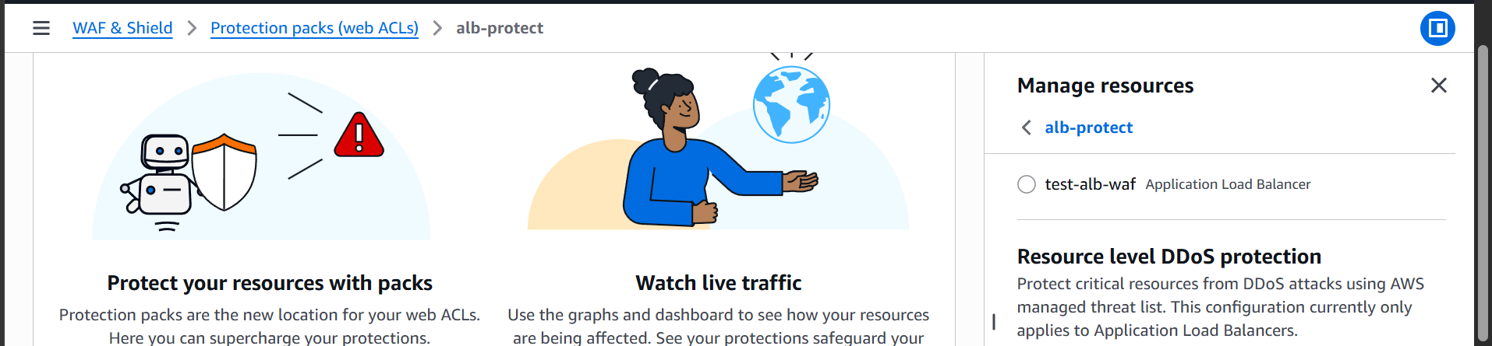
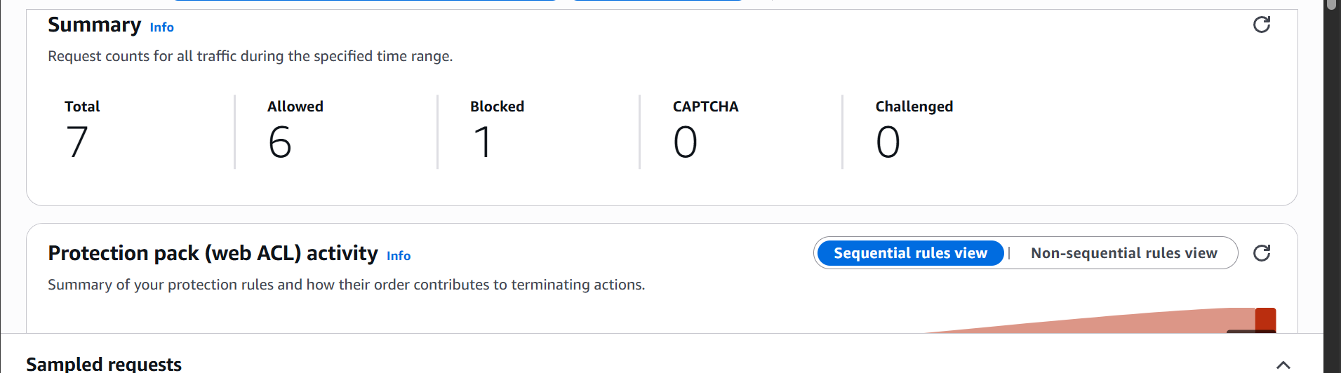
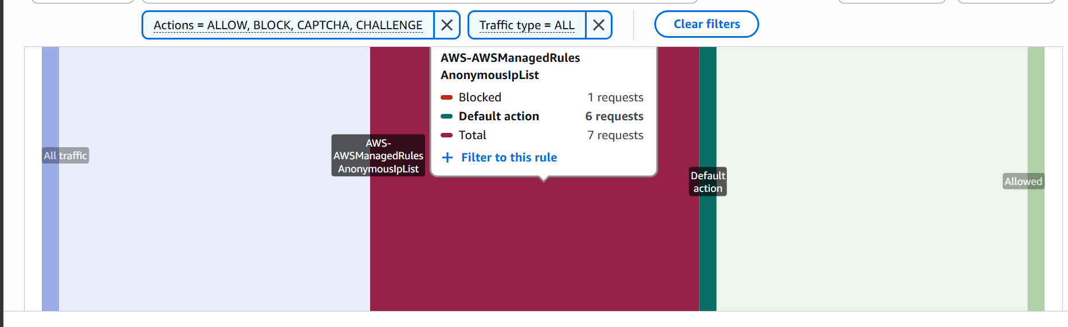
We can monitor the traffic now
When we try sql ingestion to our Loadbalancer URL WAF is blocking it
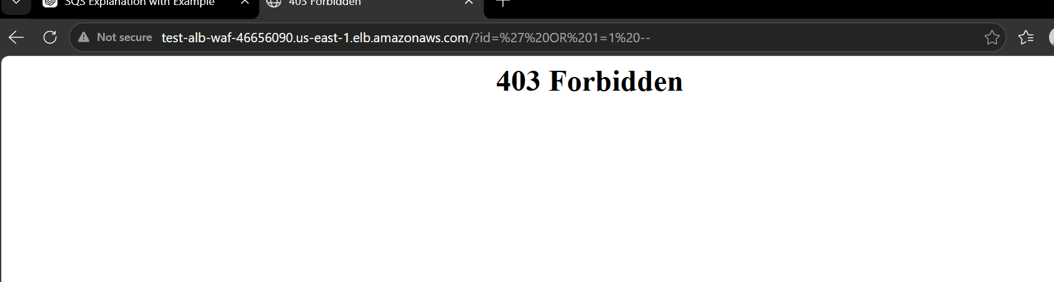
Lets try rate limiting test too
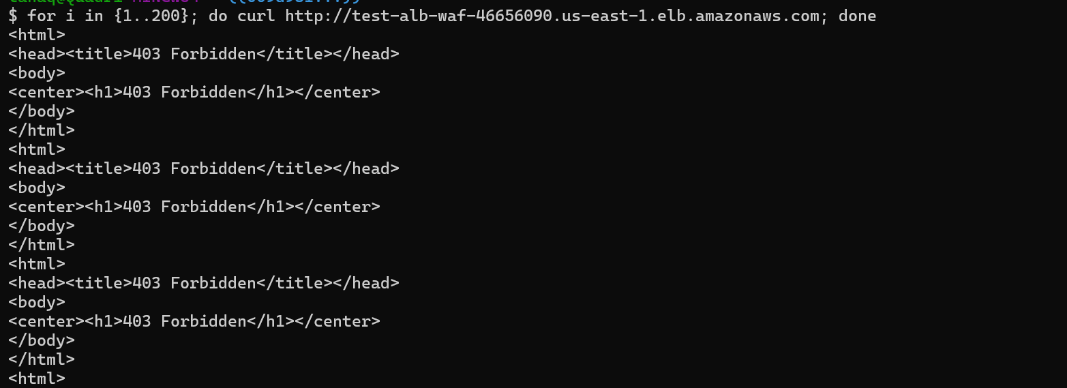
We can see that it is blocking rate limiting too.

